Achievement Gaps in Mathematics: A NAEP Data Analysis
Authors: Jane Smith, Robert Lee | Draft — Not for Distribution

Abstract
This study examines mathematics achievement gaps among eighth-grade students using restricted-use data from the National Assessment of Educational Progress (NAEP). We analyze subgroup performance differences across racial, socioeconomic, and geographic dimensions. Results indicate persistent gaps that have not meaningfully narrowed over the past decade.

1. Introduction
Understanding achievement gaps in mathematics is central to research on educational equity. The NAEP restricted-use dataset provides detailed demographic information that are not available in public-use files, enabling more precise estimates of subgroup differences. This paper presents an analysis of the 2019 NAEP Grade 8 Mathematics data.

2. Data and Methods
The data come from the 2019 NAEP Grade 8 Mathematics restricted-use dataset. The analytic sample consists of N = 413 students who met the inclusion criteria (nonmissing outcome data and complete covariate information). Ordinary least squares regression was used to estimate achievement gaps after controlling for school-level characteristics.

3. Results
Table 1 presents mean mathematics scale scores by racial group. The overall sample mean was 269.4 points (SE = 1.2). Substantial gaps were observed across racial/ethnic groups and socioeconomic status.
Table 1. Mean mathematics scores by racial group.
Racial Groups | N | Mean Score (SE)
White | 182 | 278.3 (1.8)
Black | 97 | 251.6 (2.4)
Hispanic | 88 | 254.1 (2.1)
Asian | 43 | 291.7 (3.2)
Other | 0 | —
Note: Means are weighted scale scores. Standard errors are shown in parentheses.

Figure 1. Approximate mathematics score distributions by racial group.
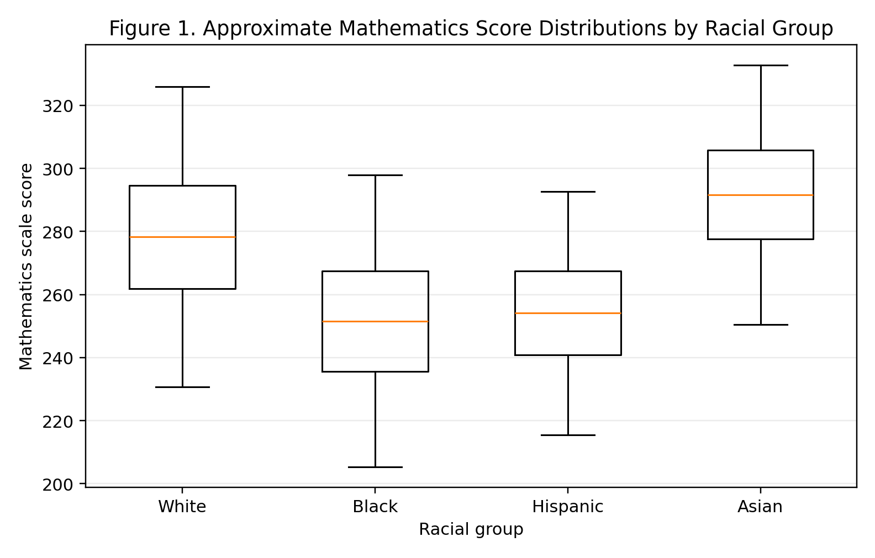
Note: The “Other” group is omitted because no students were observed in that category.

4. Discussion
These results replicate prior findings of substantial mathematics achievement gaps. The gap between White and Black students (approximately 27 points) is consistent with national estimates. Limitations include the cross-sectional design and potential measurement error in demographic classification.

5. Conclusion
Achievement gaps in mathematics remain a persistent challenge. Future work should examine longitudinal trajectories and the role of school-level interventions.

